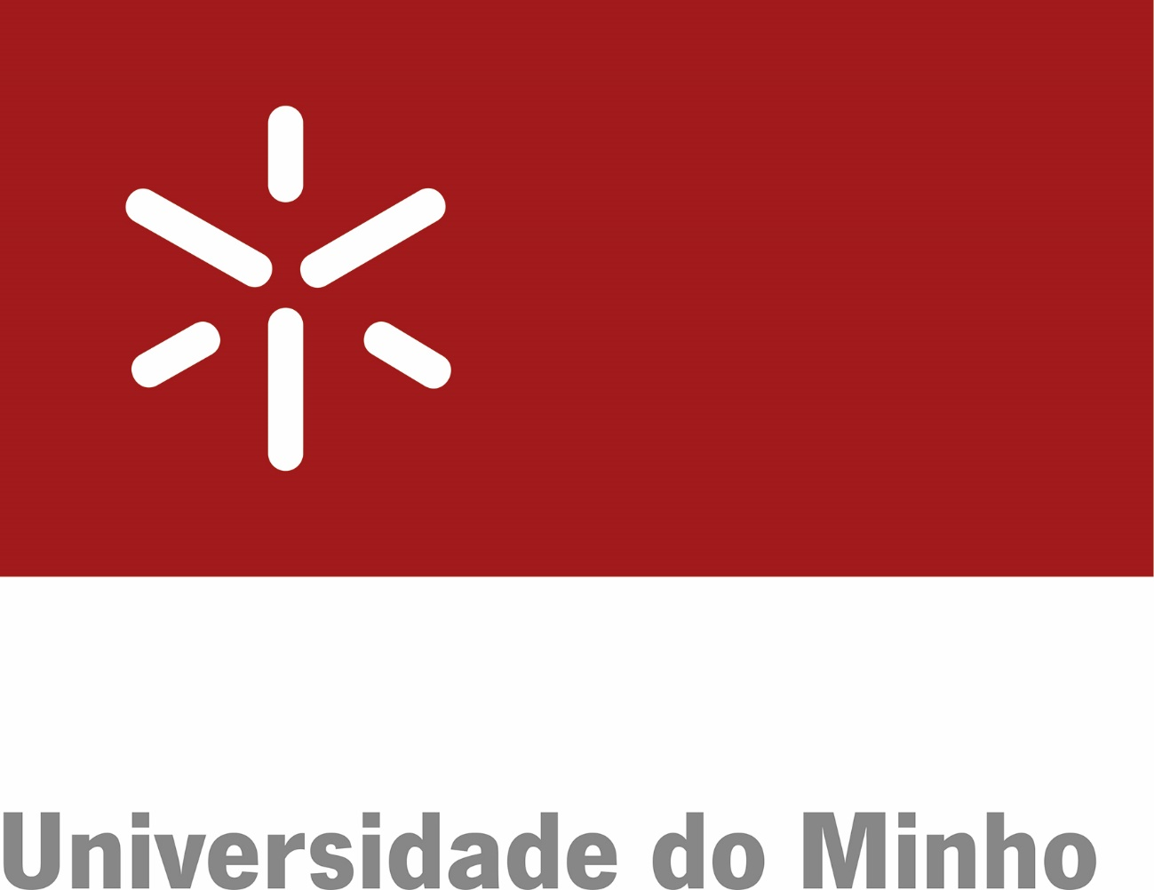 | [logo from the partner university]

[Ordinal of the Addendum] ADDENDUM
TO THE MEMORANDUM OF UNDERSTANDING
BETWEEN
THE UNIVERSITY OF MINHO, PORTUGAL
AND
THE UNIVERSITY [name of the partner university], [country of the partner university]
FOR THE ATTRIBUTION OF THE TITLE OF EUROPEAN DOCTORATE

The University of Minho, hereinafter referred to as UMinho, a public higher education institution of foundational nature, under Law 62/2007, of September 10th, located at Largo do Paço, 4704-553 Braga, Portugal, VAT 502 011 378, herein represented by its Rector, Professor Rui Vieira de Castro,
and
The University of [name of the partner university], hereinafter referred to as [diminutive/acronym of the partner university], located at [address of the partner university], herein represented by its Rector, Professor [name of the Rector of the partner university],
hereinafter jointly referred to as Parties.

Considering the laid out in the Academic Regulation of the University of Minho in force,
Considering [refer to normative provisions of the partner university]
this Addendum is signed regarding the attribution of the title of European Doctorate in accordance with the following clauses:

First Clause
Scope
This Addendum aims at implementing the goals of the Memorandum of Understanding and to frame a period of stay of the PhD student [name of the student], from UMinho at the University [name or diminutive/acronym of the partner university], for the attribution of the European Doctorate Title.

Second Clause
Doctorate and supervision at UMinho
1. The PhD student is enrolled in the Doctorate/Doctoral Program in [name of the Doctorate/Doctoral Program], from UMinho since [enrolment date at UMinho], having registered the subject and thesis plan in [date of registration at UMinho] with the number [registration number].
2. The doctoral thesis is supervised by [name of the supervisor], Professor [category] from the School/Institute [name of the School/Institute] of UMinho.

Third Clause
Period of the stay at the host institution
The PhD student shall complete a one period of stay at the University [name or diminutive/acronym of the partner university] with the duration of [number of] months, under the supervision of Professor [name of the supervisor of the study period(s) referred to in this Addendum].

Fourth Clause
Work Plan
The Work Plan and respective schedule for the period of stay of the PhD student at the University [name or diminutive/acronym of the partner university] agreed by both institutions is attached to this Addendum.

Fifth Clause
Fees
The PhD student will pay the applicable fees at UMinho and, whenever necessary, at the University [name or diminutive/acronym of the partner university]

Sixth Clause
Certificate
1. After the period of stay, a certificate shall be issued by the University of [name or diminutive/acronym of the partner university] attesting the work developed by the PhD student, which shall be sent to UMinho.
2. The PhD student shall comply with the work plan as well as any requirements established by the University [name or diminutive/acronym of the partner university] with regard to the issuance of the certificate mentioned in previous point.

Having read and approved, this Addendum is signed by the legal representatives of each institution, in 2 (two) copies, in English, of equal content and form.

Braga, __________________________ |  | [City of the partner university], ________
On behalf of the University of Minho,  _____________________________  Professor Rui Vieira de Castro  Rector |  | On behalf of the University [name of the partner university],  _____________________________  Professor [name of the Rector of the partner university]  Rector

APPENDIX TO THE [Ordinal of the Addendum] ADDENDUM
TO THE MEMORANDUM OF UNDERSTANDING
BETWEEN
THE UNIVERSITY OF MINHO, PORTUGAL
AND
THE UNIVERSITY [name of the partner university], [country of the partner university]
FOR THE ATTRIBUTION OF THE EUROPEAN DOCTORATE TITLE

WORKPLAN TO BE CARRIED OUT AT
THE UNIVERSITY [name of the partner university]

Student: _______________________________________________

Institution | Activities | Schedule of activities
University [name of the partner university] | [Describe, briefly, the activities to be developed at the partner university during the period of stay] | [Insert the period, with start and end dates, associated to the activities to be developed at the partner university]

